**Exercise: Designing components**

**Overview**

In this exercise, you will create a drop-down animated component animation in Figma using variants. When you complete this exercise, you’ll be able to add this to your reserve-a-table section on the Little Lemon website project.

**Note:** The subject matter of designing a component in Figma, as well as interactive component design has previously been covered in the **Principles of UX/UI design** course. You may want to revise or refer to the following lesson items whilst completing the exercise:

* [Design a component in Figma](https://www.coursera.org/learn/principles-of-ux-ui-design/supplement/QZ7nG/exercise-design-a-component-in-figma)
* [Interactive component design](https://www.coursera.org/learn/principles-of-ux-ui-design/supplement/x0Zh3/exercise-interactive-component-design)

**Scenario**

As defined as an opportunity in the User Journey map that you explored in the [Principles of UX and UI](https://www.coursera.org/learn/principles-of-ux-ui-design/home/week/1) recap earlier in this lesson, the persona Tilly wanted an option to select a type of occasion when making a reservation. This may, for example, allow Little Lemon to prepare something special to mark the event and save her time either by calling in advance to explain or in order to be discreet, alerting the staff to the nature of the occasion before she and her party arrive for her booking.

**Instructions**

**Step 1: Create the component and variants**

* Create a desktop frame:
  + In this frame, create a rectangle that is 400w x 80h.
  + Change the fill color to #EDEFEE.
  + Add rounded corners, with a radius of 8, and give it a drop shadow effect.

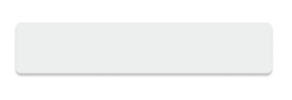

* Add some text, an icon and an arrow (a chevron) to indicate this is a dropdown menu, which, when clicked, will open up the occasion options for the user to select.

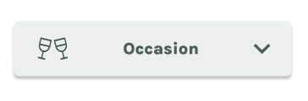

* Duplicate the rectangle to examine the list as it would be displayed when it drops down:
  + On the duplicated rectangle, remove the rounded corners and the drop shadow.
  + Add a dashed bottom stroke, delete the icons as they are not necessary and change the title to Birthday.
  + Then, group the elements.

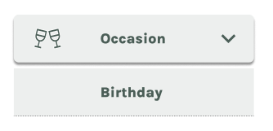

* Duplicate this box and add the other occasion options and name them.

**Note:** Although three options - birthday, engagement and anniversary - are used in this exercise, feel free to add additional options.

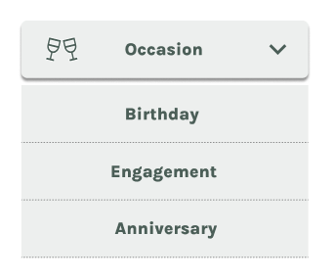

* Group all the elements and navigate to the top menu bar to create a component and a variant. These are encompassed in a purple dashed container.

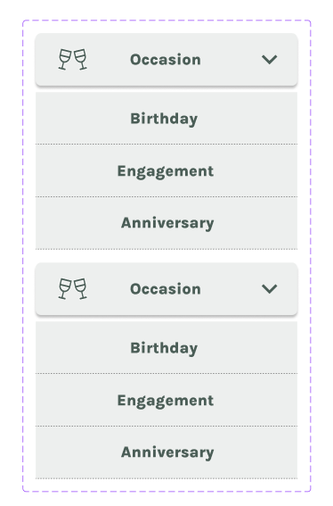

**Note:** You can easily extend the container so that you can position the main component and the variant side by side.

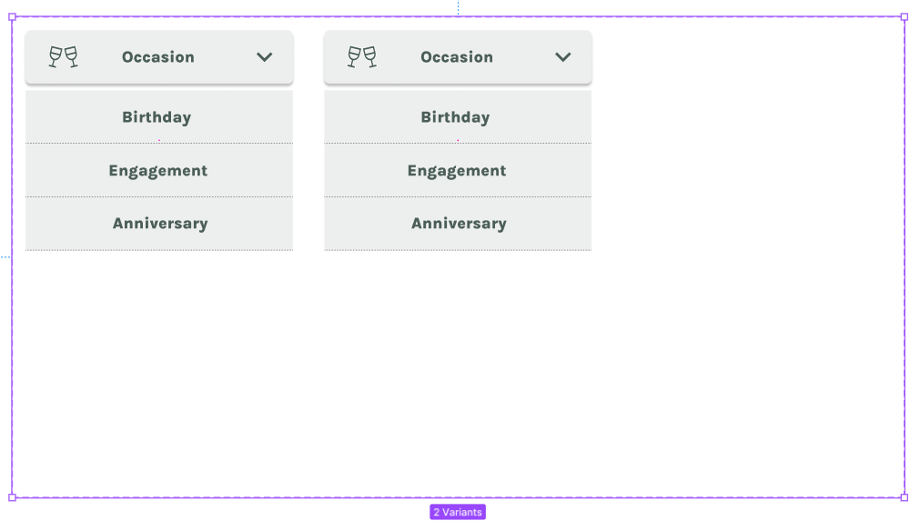

* On the left, in the layers panel, there are now two variants -the default, which is how the dropdown list will display in idle state, and variant 2, which will display the active state:

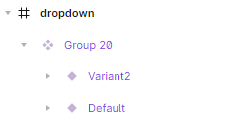

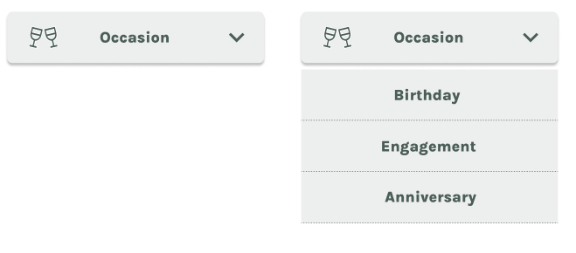

* Delete the dropdown options in the default
* Copy variant 2 and name it **Birthday,** as that's what the user will get when they select the Birthday option.
  + Delete the party icon and the other options in the dropdown.
  + Modify the arrow by rotating it 180 degrees. To make the user aware that they have made a selection, change the rectangular fill color to #495E57 and the text color to white.

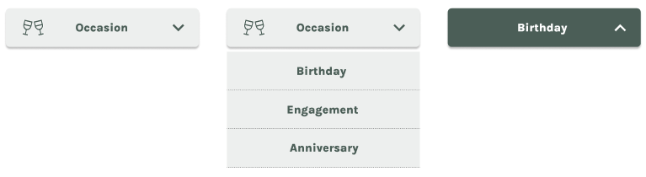

* Duplicate this variant twice (for the additional two options) and rename them **Engagement** and **Anniversary**.

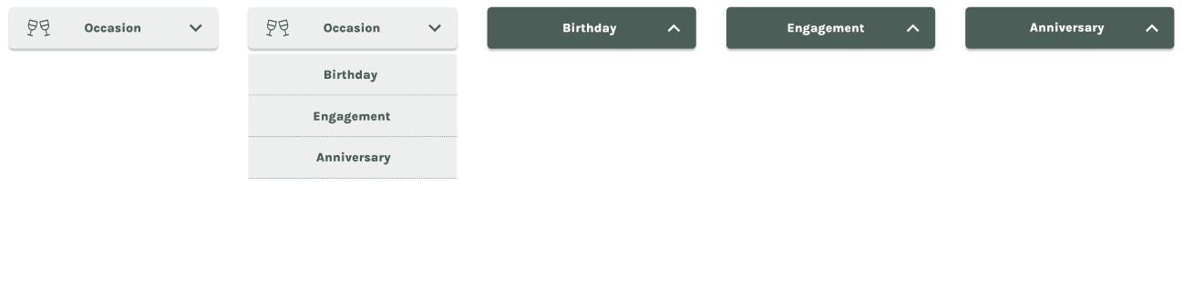

You have now created the dropdown list.

**Step 2: Prototype and animate**

* To animate the dropdown, navigate to prototype on the right-side bar and connect the components.

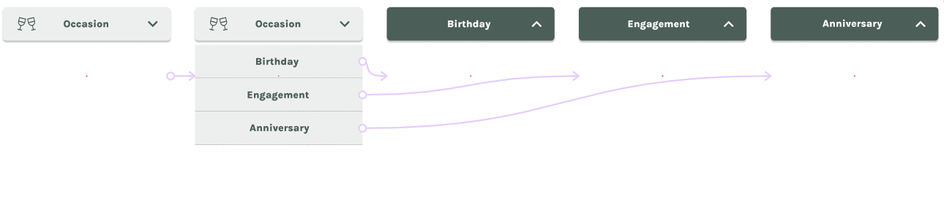

* To create a nice, smooth animation, use **Smart animate** in these connections to create a small delay when clicked.

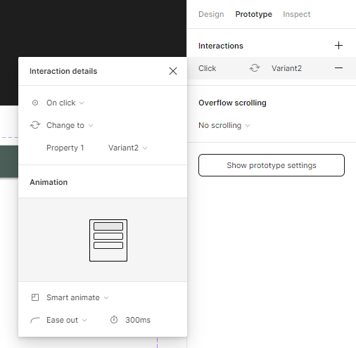

* Connect the default or idle state to variant 2.
* Connect variant 2 to the Birthday state, with the same settings: on click and smart animate.
* Repeat for the Engagement and Anniversary variants.
* Also connect these variants to the default or idle variant when the Birthday, Engagement, or Anniversary option is clicked.

**Note:** The connections covered in point 3 to point 6 are as follows:

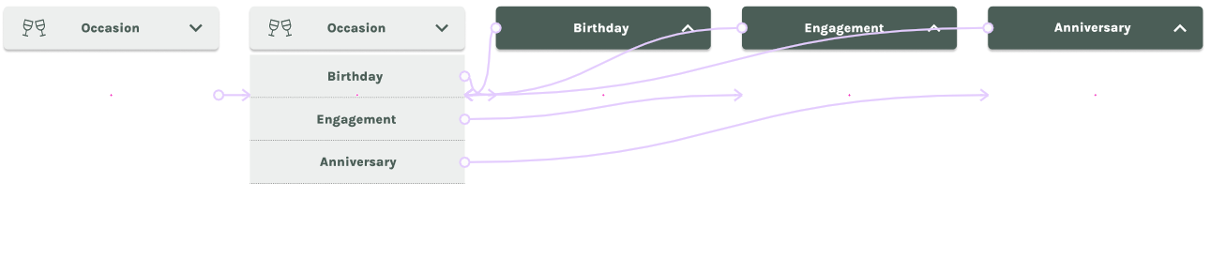

* Next, create a new desktop frame and call it **prototype.**
  + Copy the default or idle component and add it to the prototype frame.
  + Then, add the text **Select occasion**.

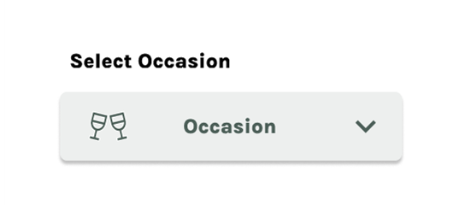

**Step 3: Present animation**

Now is the moment of truth to determine whether the dropdown menu works as intended.

* Navigate to the presentation mode.
* Click the dropdown menu. The options should appear.

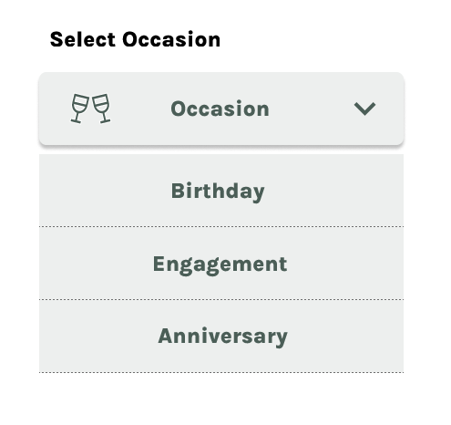

* Select an occasion. The button should change color.

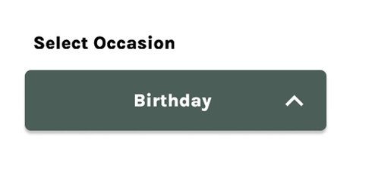

* Navigate back to the idle state and determine if you can change the occasion. This is important should a user make a mistake in their selection.

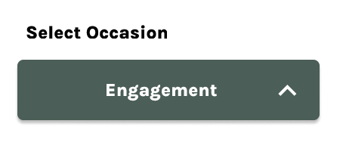

**Note:** When testing your dropdown menu, the smooth transition created by using Smart Animate should be visible.

**Conclusion**

By completing this exercise, you have created a dropdown animated menu that you can incorporate into many aspects of your project when creating the reserve-a-table section for the Little Lemon website.